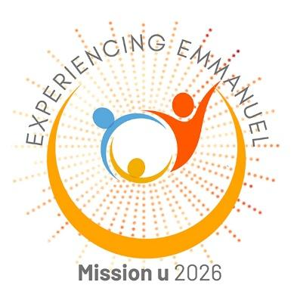
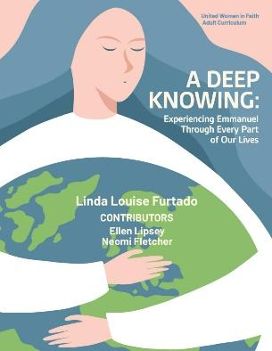
LIVE
2026 Mission u

A DEEP KNOWING:
Experiencing Emmanuel
Through Every Part of Our Lives
Sponsored by Mountain Sky United Women in Faith
& Mountain Sky Mission Team

Open to all adults, clergy, and lay persons.
________________________________
Study Description: Join us at Mission u as we explore the theme, Experiencing Emmanuel. Mission u participants will study the times in the Bible when people experienced Emmanuel, or “God with us.” How do we discern God’s presence and call on our lives in times of joy and in times of sadness, fear, or anxiety? What can we learn from these Emmanuel encounters in the Bible to help inform our discernment to faith, hope, and love in action? Listed below is the last live study location for 2026—in Cheyenne, Wyoming.
I will attend (check one):

____Cheyenne, WY [Registration due October 8]
Dates: Friday, October 16, 2 pm – 8 pm & Saturday, October 17, 8:30 am – 4 pm
Location: First United Methodist Church of Cheyenne,108 East 18th Street, Cheyenne, WY 82001
Study Leaders: Pastor Araceli Berdugo & JoAnne Shengle

At each session, an offering will be taken, and proceeds will be split between Mountain Sky United Women in Faith and the Mountain Sky Conference Mission Team.

Name:

Street Address, City, State, ZIP Code:

Best phone number: | Email:
District: □ Wyoming + 1  □ Southern Colorado □ Northern Colorado  □ Utah/Western Colorado □ Western Mountains | □ Mile High Metro □ Big Horn  Other ___________
First-time Attendee to Mission u? □ Yes □ No | Home church and city or town:
Check all that apply: __ Clergy __ Lay Member __ UWFaith __ Male __ Female __Non-binary

__ Request certificate sent upon completion of the course.

Food restrictions______________________ Physical restrictions_____________________________

Do you need childcare during the study time? _____Yes _____No

Registration fee: $65 includes: Dinner Friday night, lunch on Saturday, snacks, and beverages throughout. Your fee also covers the expenses for study leader training and travel.

Choose one of these ways to complete your registration:
- Registration deadline is listed above and registering online is easy and administratively more efficient. Please register and pay online at https://www.mtnskyuwfaith.org/mission-u/
- Or print this form, fill it out then mail this paper registration with your check payable to Mountain Sky Conference Mission u to: Pattie Klein, 1807 Ptarmigan Trl, Estes Park, CO 80517
- Or print this form, fill it out, scan it then email the scanned form to Pattie Klein at mailto:paklein58@gmail.com.

Study Leaders
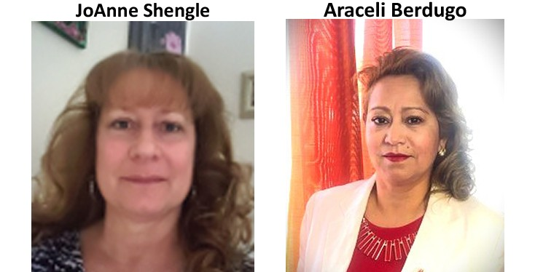

JoAnne Shengle has been a member of FUMC Lafayette, Colorado, since 2000 and has served in many ministry and leadership roles, including Church Council Vice President, SPRC Chair, and United Women in Faith President. A retired school nurse, she enjoys the outdoors, family, and friends, and is honored to serve as a Mission u study leader.
Pastor Araceli Berdugo serves in Keenesburg, Colorado, in a multicultural, bilingual English-Spanish ministry. A Methodist for nearly 30 years, she has served in many church leadership roles and says it is an honor to take part in Mission u. She and her husband, Juan, have six children and seven grandchildren, and she says serving God is her greatest joy.

